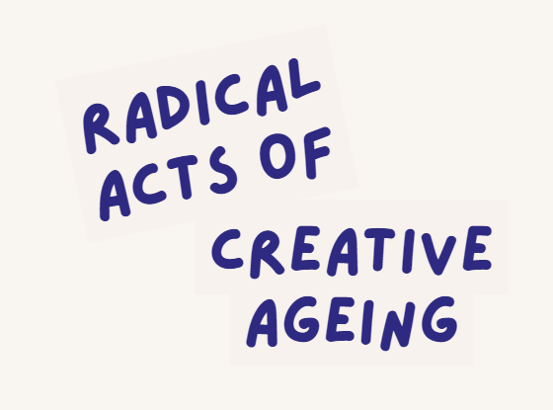
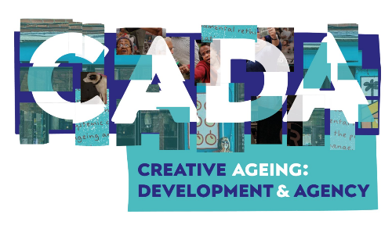

Sophie Merriman – Meet Me at The Albany
February 2026
Sophie Merriman is the Meet Me Producer, based at the Albany, Lewisham in south east London. Meet Me at the Albany is an arts and social club for people over sixty-five, developed and delivered through a partnership between the Albany and Entelechy Arts.
Weekly sessions bring formerly lonely or isolated older people together to work with artists to learn or rediscover creative skills, make friends and have agency over their social lives. Members are just as likely to be suspended on silks in a circus workshop as they are to be enjoying a jazz performance, mask making, dancing, drumming, writing poetry or singing in the weekly choir.
Group members get out and about for trips to cultural and creative spaces across London and beyond, and the film buffs amongst our members watch and discuss films at our regular Meet Me Me at the Movies club.

What first motivated you to have a creative career and how has this changed over time?
I was always going to be an artist and have always enjoyed working with people. Having the opportunity to be a part of the Arts Council’s Creative People and Places (CPP) project in Barking and Dagenham really triggered my interest and excitement for working with the arts and different communities.
I’m interested in the collaborative element of creating work and learning about the practicalities of how art can be accessed by communities in different places and spaces. I’m curious about the limitations of that: the things that get in the way of people experiencing art and making art. At CPP it was great to work in a really broad way for those kinds of projects, but I think what drew me to Meet Me and older people was the opportunity to work with a specific group and learn about that in more depth, understanding that things just don't stop when you get to a certain age. Things carry on; new opportunities can happen. Meet Me has given me the chance to get involved in a much deeper way. I’ve always got on with older people. I lost grandparents when I was quite young and they were a big part of my life. So I’ve always had a connection of being around with different ages and experiences that I felt comfortable with and was interested in. Working alongside Meet Me participants has given me a chance to challenge what I thought getting older looks like.
To challenge your thinking or that of wider society?
Both really. And I guess seeing what it could look like. I didn’t really know. Within my own family people have got much, much older. What does that look like? For me it’s been an ongoing discovery of what people want to do, what people can do. I feel like I’ve very much become an advocate for older people because I’ve learned so much from them.
Did you ever have a sense of kind of your own internalised ageism that informed or triggered your work?
I think there is an element of that. It’s hard to remember because I feel I’ve changed that by challenging it in this space. If you're working with someone who is new to the group, or someone who wants to work with our members, there is sometimes an : (cute sounding) “Ahh, that’s such a lovely thing” moment. And I think: No!!! It’s not “Ahh”.
When I first started, I was very risk averse. Everybody seemed to be very frail. I thought that I would need to simplify things in order for people to get involved. It’s been an ongoing journey. Now I realise you can’t make those assumptions. It’s not an “Ahh” moment. You wouldn’t say that in another situation to a younger person in the same context. Very quickly I learnt from the members when I was being patronising. I like to think in the beginning I wasn’t, but there’s always an element of slowing things down or asking specific questions.
I always remember the massive learning curve when as a young artist I first worked with older women from Bermondsey, south London. They had lived through everything the 20th century had thrown at them: two world wars, tremendous poverty. They were gentle and savage to me, both.
That's it! And it’s not about anybody being rude to you, it's just about the reality of the situation. “Hold on a second, we are people you know. We’ve got something to say, and we are just the same as everybody else.” It is interesting the difference between how you challenge that kind of ageism, the way that you approach it and speak about it. How it informs the types of activities that you're doing, versus adaptations to the group’s specific needs. You need to operate on a level that ensures everybody gets a chance to be part of the work in hand, rather than dumbing anything down or simplifying it. It is about instruction and clarity.
I was challenged by my pre-conceptions that older people don't like change. Of course, change is sometimes harder. Many people have been through a lot of change and it’s not always easy. But in the group people were up for it! People were up for trying different things. As long as you have been clear and have a journey or a reason or an explanation, as to why this change is happening then people are on board with it. I think it’s interesting, this perception that as you get older you get more resistant or stubborn.
What does Radical Creative Ageing mean to you?
As a younger person I guess I think it’s interesting to think about creative ageing in lots of different layers. It's a hard term. In a way, should we have to have radical creative ageing? Should we not just get rid of those stereotypes so that the radical is the norm.

Because it should be ordinary?
I guess it’s for people to have opportunities to do things that they are passionate about. It’s definitely something about visibility. Having people visible, doing things in different spaces and just challenging as many people’s expectations as possible in all of the different ways. At Meet Me I think that happens, whether we are in the café or when we go and do trips and visits and stuff, going into other spaces. I think that that’s radical: bring a whole group of people into a space where they wouldn’t normally be. The Meet Me choir did a recording at Goldsmiths Music Studio. Nobody in the group had ever been in a music studio before: “All of these older people, should they be allowed in here?” There were loads of hazards if you think about it in a practical way. So in this context, radical was being and creating in different, just different spaces and places. But also, it needs to exist more widely within society.
So it’s like reclaiming the ordinary?
It’s challenging that and creating a space where people feel that they can be, where they can do, and they can be positive and they can find, whether its escapism or whether it’s a distraction, or finding ways in which they can deal with many of the everyday challenges that they face. There are challenges that people experience as they are growing older so it is important to make sure that there are spaces for people to be supported to challenge that for themselves as well.
Just walking into the Albany this morning, you get the sense of that. Having the space where people can literally connect and engage in those ways. It’s so vital.
And again the word radical feels like it needs to be big and needs to be bold, and it can definitely be that and it’s great and the big campaigns which are about ‘Age without Limits’ and all that , the public campaigns about the visibility of older people in different places is fantastic, but I think that it also exists in this quieter way as well. It is important to build trust in different spaces and communities. There needs to be peer to peer support. People need to feel that they can reciprocate and help others as well.
It's almost like you need to have registers for the development of relationships; ways of celebrating the way that the work is enabling relationships to grow.
I think it’s also about individual creative representation as well. People still care about how they look and how they dress and we tend to forget that sometimes. It’s about celebrating the small stuff as well as the great stuff that people are making and doing.
If you were to write a radical creative ageing manifesto, who would you write it for? Who needs to hear this conversation? And what would your first call to action be?
It would be something about assumptions. I think it would be for everybody else. Not for the people who are getting older. It’s very much about how people react and respond and create spaces that are stopping people being able to be creative. The manifesto! I wonder what our members would say to somebody about that? I think it would be about finding a simple accessible language, how we speak to one another.
Maybe the question is the problem. Perhaps the manifesto is not the right way of going about it because it makes you self-conscious about language when the words should be ordinary. It’s just about a recognition and connection between people, with people, who have different experiences and are not often allowed to, or are in a position, to share that.
Maybe it’s about listening to the people who you are trying to connect with or work with, as a starting point. Because without their voice, it just doesn’t matter. It doesn’t really matter about what happens next or what moves forward. We did a code of conduct a couple of years ago at Meet Me and that was quite helpful. We worked with a poet to pull that together. The words described what we are about and what are we committing to. I think a manifesto comes from lots of different people but maybe listening to the people you are working with, listening to yourself, speaking to people. You just need take a moment to listen.
In contrast to people when they’ve turned their listening button off and are projecting a weird notion of who they think they are talking to without realising or knowing. I find that constantly; that forgetting by people that they are in the presence of a life lived, that the whole experience of a life lived, in every sense, the domestic life, the professional life or the work life or the family life.
And valuing that. Valuing the years that have gone by. Valuing the life that has been lived of the person who you are speaking to as well.
Is there anything else…
Radical creative ageing. It exists in lots of different formats, its thinking about creativity in its broadest possible sense. We’ve noticed whether it’s about cooking and people talking about the big meals that they are still cooking up for their families and they are still sharing their individual skill and passions in lots of different ways.
There’s like a natural pride. People are still proud in what they are doing and having a chance to have space to do that and perform and be seen in different ways.
And as ever with any creative process there is the challenge of finding a balance process and outcome. What are we doing and what are we working towards? People really enjoy the process and that’s the change maybe. But people also love to have something to show for their time and work. People want the “Look at me, look at what I’ve made!” moment. “I know this is for a purpose, I know this is for someone else as well.” So as part of that radical creative ageing, the process is definitely how we relate to one another. Both the peer to peer and the coming together of people of different ages is really an important part of that. Especially with our teams of volunteers, who are younger. That is really important, to always have friends of all ages.
It’s feels so important that Meet Me happens in the open and publicly accessible café space within the Albany. It’s not hidden away in a private function room. It is visibly part of the public life and energy of the building. Strangers get drawn in.
They meet artists, they meet new volunteers, you meet new members. That is the beauty of that, it’s great. The visibility of relationships. People’s relationship to one another, people’s relationship to where they live. It’s also about building trust, pushing outside of everyone’s comfort zone. If everyone trusts one another, they’ll take risks. They’ll give it a go.
Sometimes when we’re planning things and it’s “what about this?” and “what about this” and we’re like…we have to check ourselves. “Let’s just see”. “Let’s just see”. “Let’s just go with it. People might not like it. They might hate it and that’s actually fine as well. I think it’s about learning. Everyone always talks about really loving learning. So learning about other people, other cultures, histories, creative skills, new songs, new movement. People love to learn.

