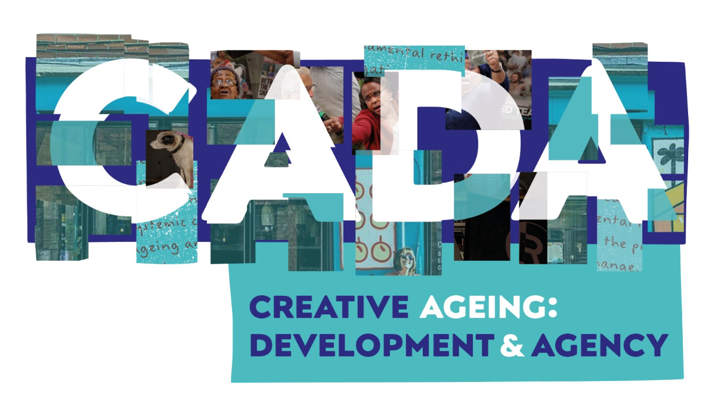
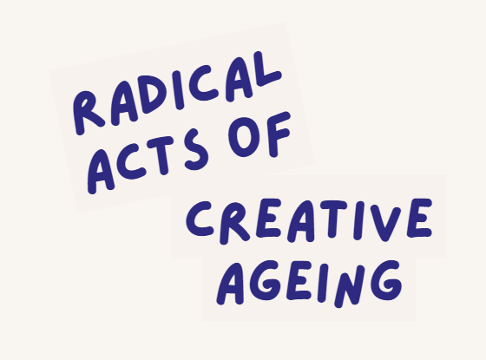

Greta Mendez – 1st October 2025

This transcript has been lightly edited to make it easy to read. For the audio version click here, for the video recording click here. This is a transcript from the interview, the text may divert and jump around, just as natural conversations do.

Hello and welcome to this podcast for CADA, the Creative Ageing and Development Agency.

My name is Elizabeth Lynch and with Aarti Prashar, I'm the co-chair of the organisation. This podcast is an interview with Greta Mendez. Greta is a dancer, a choreographer, a movement and theatre director, and a carnivalist.

She's a freelance artist who focuses on new and experimental work, but also draws on and re-examines traditional forms and ritual. Today, we will be hearing her share her thoughts on our theme for this podcast series, which is Radical Acts of Creative Ageing. Creative ageing activists have described creativity as ‘thinking by doing’, and radical as ‘something that makes your heartbeat faster.’

CADA is exploring what radical creativity and ageing is from a wide range of perspectives. Today, I'm delighted that Greta has joined us. Greta, we're going to ask a series of questions and we'll find out a lot more about your absolutely fascinating career.

But first of all, let's just go back to the beginning. What motivated you to have a creative career and how has this motivation changed over time?

Well, to be very honest, I didn't even think of having a creative career. That just came to me.

Dance, I started life as a dancer in my creative bus, but I lived in a tiny village called Faisabad in Trinidad and Tobago. I grew up in the time when there was no television or nothing, so creativity as an artist, that didn't enter my landscape at all. But while walking through the school, as a 10-year-old, I think I was, the school's inspector for physical education said, this little girl looks like she can dance.

And that was my entry point. Her name was Eileen McSween, to be precise. And I started dancing at the age of 10 and I found the most amazing world.

That's why it's imperative and it's fundamental to me to always have dance in there, because dance saved my life, because I was a very unhappy child and neglected quite a bit. So I entered the dance. I was never, as far as I'm concerned, I'm not a dancer.

I enter dance and find out what's in the dance, inside of that. And that's my entry point. And then I made the very radical move to leave Trinidad, because I had developed such a state, and left Trinidad so I can learn more, see more, and then go back to Trinidad with greater knowledge, she says.

I think that answers the question, does it?

How has this motivation changed over time?

Well, the motivation and the imperative in my soul hasn't changed. I am only truly happy when I dance. But how it has changed is that I forgot somewhere in my journey, but I know exactly when, I forgot what my imperative was, what was essential for me and my growth as a creative being, and got involved in the social politics of being in England, on Europe.

Because the problems you have here, I would not have encountered it in Trinidad. The level of racism and the marginalization of Black dancers in contemporary dance, because at that period, there were no contemporary Black dance companies, and people tend to forget that. And there were African groups and stuff like this, and it was said that we couldn't do contemporary dance.

So we set out with the brilliant Naseem Khan, you know Naseem Khan? Yes. And to create a company that will address all these things that kept us on the margins. And so we opened, started MAAS Movers, that started the contemporary dance, which is actually fed according to Dick Matchett.

He said, had it not been for that, we wouldn't have what we have now. And of course, you know, so I had to stop my own personal, in a way, my own personal development, and actually focus on that and develop, because I ended up directing the company and focus on that. And I think by the time I came back to my own journey, one of the things that's central to what we are saying, there's a thing called ageing.

So although, you know, one was looking 18 on the outside, the ageing thing is going on on the inside. You know, the clock is ticking, biology is happening. So therefore, by the time I began to focus on me, and what I wanted to do and what I wanted to say, my physical state had changed radically.

My body decided, and remember it's dance we do, dance. So your body is crucial, is fundamental to it. And my body had become this thing that I no longer knew, or recognized.

Suddenly, it was just bloating out. I mean, like bloating. It didn't matter what I did.

It didn't matter what I did. It was excuse my language was saying, excuse me, you have worked me so hard for so many years. I am not doing anything you say.

So therefore, it sent me into a downward spiral. Because no matter how much I tried to come up, my body was not responding. So when you send me this stuff, I'm saying, I'm thinking radical, my body did the radical move.

It didn't matter what my head was telling it. It's going, I am exhausted. You have worked me to the nth degree.

I am doing nothing you say. And so it has changed.

So maybe the next question is, interestingly, following on from that very provocative account. Do you consciously challenge your own internalized ageism in your creative practice? And what inspires you to do this? Because you have not stopped?

Well, actually, I had to go through an indulgence, which you quote somewhere there, it was an interesting shift. Because at some point, I had to accept, I went to classes, as you know, so we hardly eat anything. So it wasn't diet, it wasn't whatever.

And so certainly, from having a washboard, very flat tummy, I didn't use to have breasts, I had breast and belly. And I had to do the radical move. I'm going, okay, you can't change this.

No matter what you do is not changing. This is what you have, you have a big belly. I prefer the word tummy or belly.

I'm not sure the dynamics of that right now. You look like a Botticelli woman. Because, you know, all the voluptuousness, you're going to put that body back on stage.

Because you love to dance. You love to express social issues. And you're going to say this is who I am now.

I'm no longer that leaf athletic, could do split jetties and all of that. This is what you have. This is what sometimes some woman's bodies develop to, you know, and no matter what I know, they're going on about fat.

I am not overeating. I know that. So I did this work called Indulgence.

And I featured this woman, this artist character called Madam Glow. And anything could come out of her mouth. But because all my work is actually kind of also rooted in politics and colonial politics, I had to bring in politics.

So I use the beauty industry. And I was actually a lot of the text, you will see political quotes, you know, like I would say, you know, to, you know, that I was using, because, you know, there was a time when they were telling go, if I use this cream, you know, it will precision target, it will precision target, will precision target, it will be just as good as the bombs that they're dropping on Afghanistan. Yeah, it will wipe it out, because I was very much against it.

So I was linking in stuff, you know, so it wasn't overtly, but it was there. And stripped myself, not totally naked, but lifted my and showed my breasts and my fat tummy and go, okay, fine. And that was a point in terms of a radical move that I made.

And I performed it as you at the opening at Riverside Studios. I did it in Delhi. I did bits of it in Trinidad.

Yeah, I did it in Delhi. Although in Delhi, which I thought was very interesting. They asked me not to take my top, not to show my, I go, but Indian woman, you know, they have these beautiful tummies that they wrap around in their saris.

And it's out and she was like the director, producer was going, no, no, no, you cannot. So eventually, I surrendered. So that is where I made a radical.

And I had to be very brave in a dance, in a dance world. Yes. To show my floppy belly, because it wasn't firm either.

It was just, I mean, really like a Botticelli's a woman, you know, those big voluptuous ones they have. And that was a radical shift. Yeah.

So I think now, what does after those experiences, what does radical creative aging mean to you?

Well, it's, I'm in a bit of a no man's land at the moment. I don't know if it's coming out of COVID, the effects COVID had on me, because although I was saying that I couldn't do it, I was very, very flexible. I could move like, you know, people would look at me and think, oh my God.

And then suddenly I start moving and go, my God, look how she's moving that, that voluptuous or fat or whatever body. But COVID, something has gone in a third dimension. And maybe I'm in an incubation period because I can't find the next shift, you know, of what I do.

Am I just going to surrender to the fact that my physicality, I was saying to somebody the other day, it felt, and it feels like the dance has left my body. My dance has gone. And therefore, if my dance has gone, and I don't mean to be tragic with this at all. I then question what use I am on the planet, because it's through my dance, I was able to tell stories, not personal stories all the time. The first time I think I did a real personal story was three or four years ago when I did that stuff about my father and the whole issue of identity, because what am I, who am I, this, you know, mixed race, biracial, all this nonsense. And maybe I'm in a period of forced, because this radical thing is very interesting, because biology impacts so much.

If I was a writer, it would be different. If I was a painter, yeah, what the body and what it is doing, despite what I am doing, forces you. So do I find new ways, which means maybe that's the period I'm in, because you know, there's sometimes you have to be still, you have to do nothing.

It's almost like it is an incubation period, and maybe something truly radical, because I should be having another radical shift, like when I did indulgence, when I dealt with the fact, and I questioned the whole beauty industry business, you know, and that was a very good piece, which needed a tour and all of that. But somehow, I never have the managers around me to help me, you know, take it everywhere. And I think that's, I'm hoping that's what it is, that I'm in, and because it's the first time in my life, I haven't had a real good creative idea.

And I don't like to just do work for doing work's sake. So, you know, you know, I can do that. But what am I saying? How is it affecting the society within which I live? Because I never do work totally for myself.

I have to look at the society within which I live. Yeah, how can I do something that reflects the fear? Well, I am fearful anyway, the loss of hope that a lot of us feel, because of the current situation we are in globally. How do I reflect that loss? That loss of hope, you think, what is shifting? You hear in the Caribbean, they're going, well, you know, we could be taken over as well, you know, if this this shift happens.

So, so I am most probably in the best state I could be, or I'm in the worst state I could be, because it's the first time since as a 10 year old, I have had some radical idea of what a piece of work I could do, you know, because I've had things like from coffee beans to disinfectant, looking at the thing of coming out of a colonial Trinidadian colonial experience, coming into the colonizer's world. Yeah. And this is a world that colonized us.

But this world that we were sold, that was you know, made of gold and silver or whatever, suddenly realized, no, it isn't, you know, it's a world that is disinfected. That's why I called it from coffee beans to disinfectant. And strangely enough, I got that walking through Covent Garden, you know, I was walking down Monmouth Street, I think it was, and this incredible smell of ground coffee from a coffee shop was just coming.

And I walked right into this disinfectant. So it's, it's, it's... But listening to you, this is not, this is off script, but you talk about hope. And you know, how, how can we be hopeful at the moment? And you talk about the impact of colonization, the long term, the legacy.

I know from talking to others, young, much younger people, that you have been an inspiration and somebody that they look up to. So is that maybe, is it, is it with our younger people that you can move, you know, get out of, make this shift for yourself and continue to inspire them to think radically, creatively, differently? But you see, that is where I tell myself off. There are two moves, you know, there are moves you make in your life that you did in one, one minute, and it affects your whole life.

Because I've been teaching, I've been in the background teaching and motivating young people for quite a few years now, but I've done it in, in, in, with actors. And so I have been teaching, I have been motivating, and I ended up feeling very, very burnt out, very angry. Because of course, it's a constant taking.

So I have been doing it. But I've been doing it with actors. And I haven't been doing it with dancers, but, but I've been working with young people.

Few people know, there's a big agency now called IDSA. The whole system that they put on was taken from a summer school I used to run for Tallow, a theatre company. And he took that same model, and he created a school using that.

Now he has credited, credited me. I mean, it's strange enough long ago, that's what you get paid for. But out of that, and I have to look at things like that, out of that came the John Boyegas, the Letitia Wright, all those people who in Hollywood now, Idris, Damson, Idris, that created and gave them, now they are millionaires by the way.

So I have done, and I think I'm going, and that's why I started, my voice is going. And I started for the first time to look at myself, because I haven't looked at myself. I challenge everybody, I push everybody.

What I don't do, greet her, I run away from her. So this is a really interesting point about doing something for yourself, but also you're running away from her. So maybe we'll come back to that.

But if you were to write a radical creative ageing manifesto, who would you write it for? And what would your first call to action be?

Now, that one, again, I found difficult, because it's summarising it. My call to action, strange enough, is still with those young people, because in a way that is the future, yeah? And they're developing and they will change, and the world is changing drastically. You know, what I could have lived under a dole, I don't know if you remember the dole.

A lot of us as artists lived under dole and created amazing work. You can't do that now. So any young person, any kind of young person, and the Arts Council funding is changing, right? And I think anything I would write now is actually trying to focus on how we could set the young ones coming up on a healthy path.

Because I think for too long, the creative industry, for us on the ground, us who are doing the work, was kind of unhealthy. We weren't very well paid, we weren't very well fed, we did work in nasty stinking studios, we did work at midnight, you know, when people go on. And it's how you create, oh, I can write something that sets out a path that the young ones come out now would not be burnt out like I was in your 30s.

Because that should be your, you know, you should be at the zenith. So how do you create a system, an industry, to guide young people, that when you reach my age, you're not afraid that you don't have enough money to live out the rest of your life. Because the world is changing.

There was a time I remember, God, I'm old, I'm very old, actually. How old were you, Greta? Very old. I remember when I was growing up, you know, teachers and doctors and people, you know, people fed them, they took pride in them.

You can't get any of that support now. So young people coming up in the creative industry is to also look that I love it, it's compassionate about it. But I was talking to my goddaughter the other day, who wants to dance.

Well, it wasn't my goddaughter, my goddaughter's sister. And I was saying to her father, yeah, you know, celebrate and encourage her passion as a dancer, but also let her develop her other artistic potentials, be a writer, be a songwriter. So this, because it's about looking at how you sustain your creativity, so that when you reach senior years, you're not scared that the fact that you don't have enough resources to celebrate the rest of your life and all that you have done, to be very honest.

Yeah. So you don't end up feeling like sometimes I sit down and go, what have I done? What should have I done? Because it's not reflected in anything I have. You know, I don't own my house, I don't own a car, I don't have a bank account, because my passion for the art, for dance, my passion to to encourage people to celebrate other people's talent, to bring other people's talent, to neglect oneself is not good.

So if there's one thing I always say to my students, though, is don't neglect yourself. You've got to feed yourself as well. You've got to take moments away from yourself.

It's not selfish. I was brought up to believe anything you did where you focused on yourself was selfish. That it's and that although I think the young people are understanding that more and more now, it is not selfish to say no, I cannot do that.

You know, but we have this. No, I cannot. I'm too tired.

You get up and you go; you break your wrists because you're so exhausted. Nobody helps you to the hospital. You have an operation.

So I think for the future, if I'm doing well, I don't do it in the future. I do it now. Anybody I'm teaching a lot of young people with which I kind of disturbed me slightly was that a lot of young people are going into dance and going and making companies right away.

I'm saying to them, no, no, don't do that. Develop your dance first, develop your choreography first, because running a company is so, so much work. So it's how and I have done it in terms of everybody I work with to celebrate yourself, like yourself.

And I think the industry in some ways, because I recently worked with a wonderful woman called Alexandrina Hensley. And she because I was ill at the time, and she supported me through that, which was a shock to my system, because I hadn't in our sector. So much.

Because it would not move. And she supported me through that. Never made me feel guilty that I couldn't.

Yeah. So I. Because there's a thing called biology, that's your radical move on the current there. And unless you have taken good care of yourself in the 20s, 30s and 40s, it comes back to bite you.

And that's for me, is looking at how you develop your foundation. It is a foundation, you said, isn't it? In your script. Yeah.

How that that those years are crucial so that you have a very as healthy as possible, because genetics is genetics, right? It could still come and bite you. But how you end up having a healthy, creative life in your senior years. And I always said if I had developed because I do like writing. If I had developed my writing skill, I would be happier because at least I'd be having, you know, an output. So I think anybody in any creative field is the to develop. Multi, multi, you know, multi.

Because in actual fact, none of us are one dimensional in our creativity. Yeah. You know, and so therefore to focus on one thing like I did.

To uncast everything else aside. But in a way, I didn't because I choreographed and all of that. So I must be too hard on myself.

You must. But about about care and self-care, care for others, looking after yourself. The the the the image is suffering from, I think, a poor signal, Greta.

So I'm worried that it's come back now. But I think. Yeah, because I'm OK.

Am I there? We're fine. We've come to the end of our time allowance, but that was super. You've raised so many issues there.

I'm sure there's going to be lots of comment. And as you know, we're going to make this recording into a podcast and a fanzine. So we will be doing some editing on the interview as well.

But you've given us so much food for thought. Thank you. Thank you so much.

Is there any. Would you like to have the last word? No, I always have the last word. So this time what I'm saying is I. I hope.

You know. That's what we have to live by, that things will get better and. You know, although I don't particularly like that would know that I'm saying it is that how we do a radical shift.

What. A radical move is needed right now. You know, a radical move because we need it.

Yeah, I mean, definitely. I'm not going to go on stage and do a little plonky plonky dance dance things, you know what I mean? Yeah, it's it's it's it's need. It's time for something seriously, a radical shift.

And I think some of the young people might be there. It would be interesting to see what they do at Notting Hill Carnival. Yes.

If they make any kind of statements, anybody designs anything radical, I doubt it. But I mustn't be a pessimist.

